**Data Methodology 1:**

**Step 1: Storyboarding.**

* Went through the data to get familiarized with it and noted down important fields.
* Made a mind map of the various slides of the presentation.
* Made a rough template based on this mind map

**Step 2: Data Wrangling.**

* Loaded the provided dataset into pandas and tried to understand the variables present.
* Analysed each attribute and checked the data type of each column.’
* Then calculated the null values in each column:

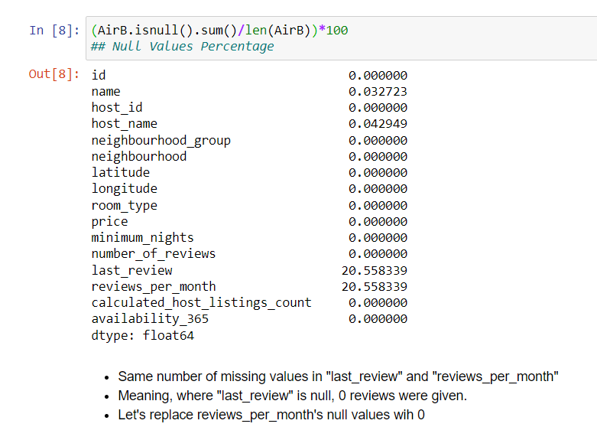

Thus, replaced the ‘reviews_per_month’ column with ‘0’.

* Checked the spread of the numerical variables using Box Plot:

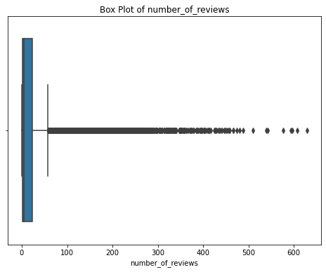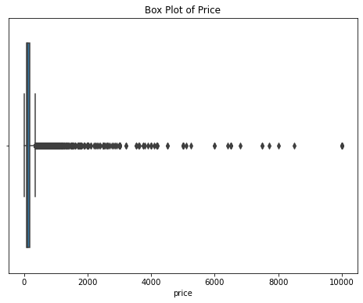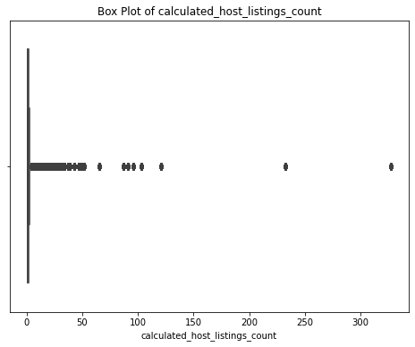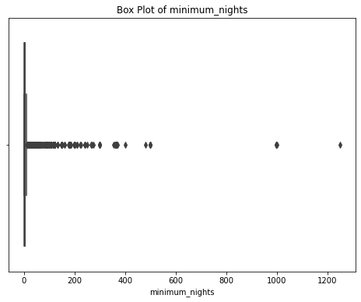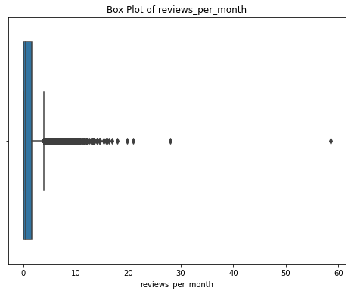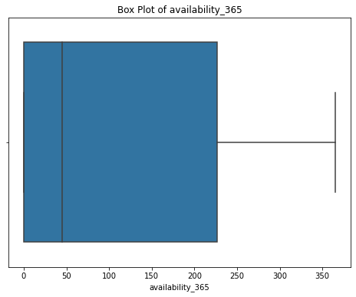

We observe in the above given box plots, that there are a lot of outliers. These can massively skew the data.

* Thus, we got rid of a few outliers using the IQR approach:

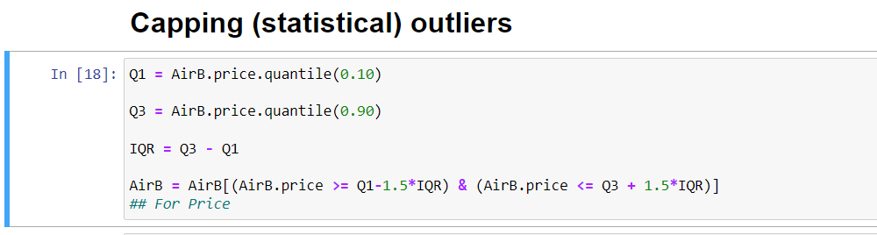

This method was done for all numerical columns (except “availability_365” since it did not have significant outliers).

* Now, boxplot were plotted again to see the difference:

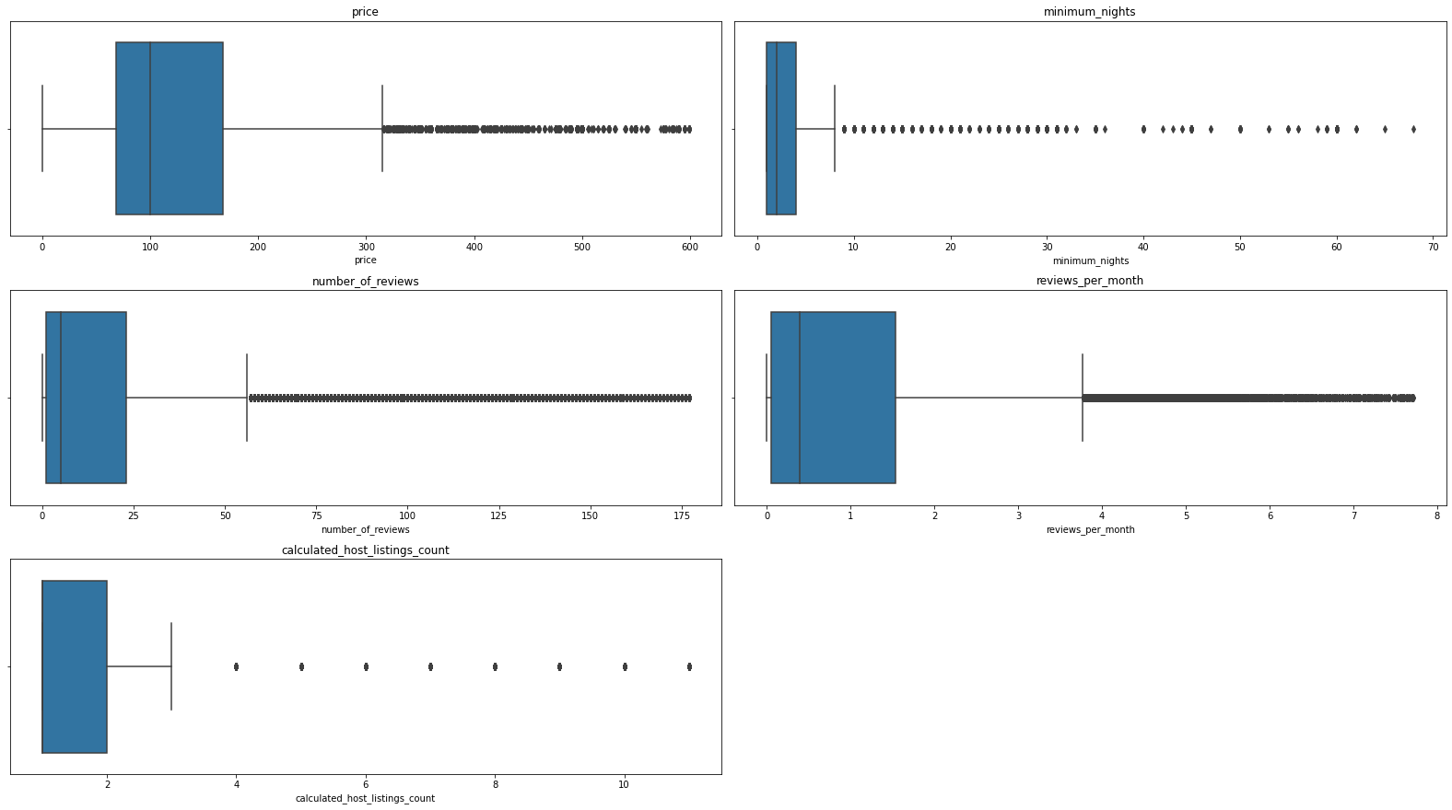

We see a significant difference in the Box Plots now.

* Loaded the data in Tableau for visualization.
* Created a calculated field for **Average number of reviews**:

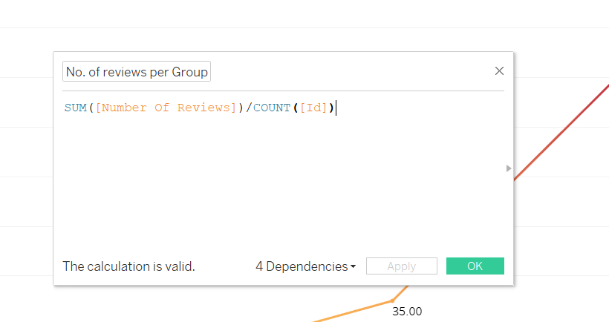

* Created bins for price range:

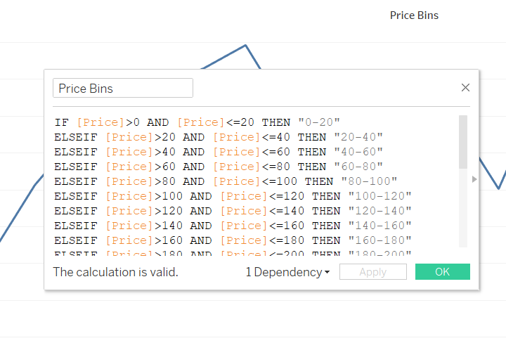

* Created Bins for Minimum number of nights offered:

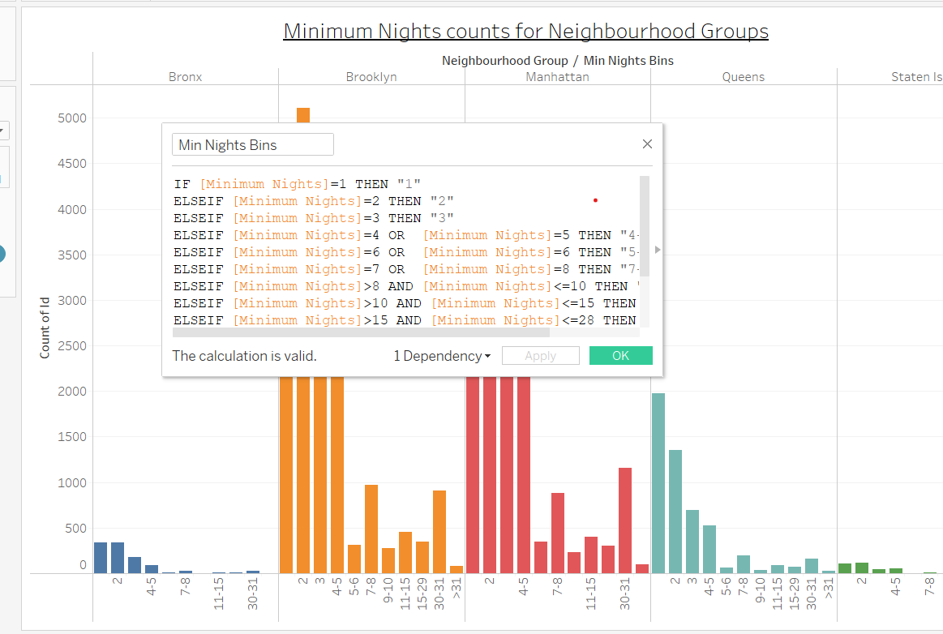

**Step 3: Data Analysis.**

* Compared the average number of reviews (popularity measure) with the median of number of available days in a year for different room types:

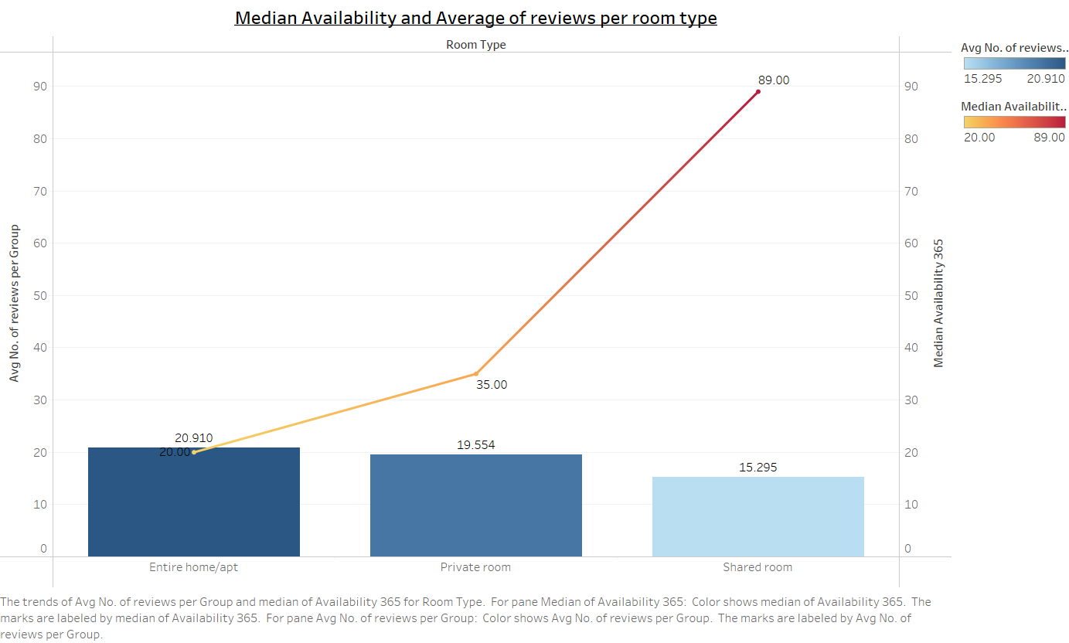

* Checked the trend of average of reviews w.r.t increase in the price range:

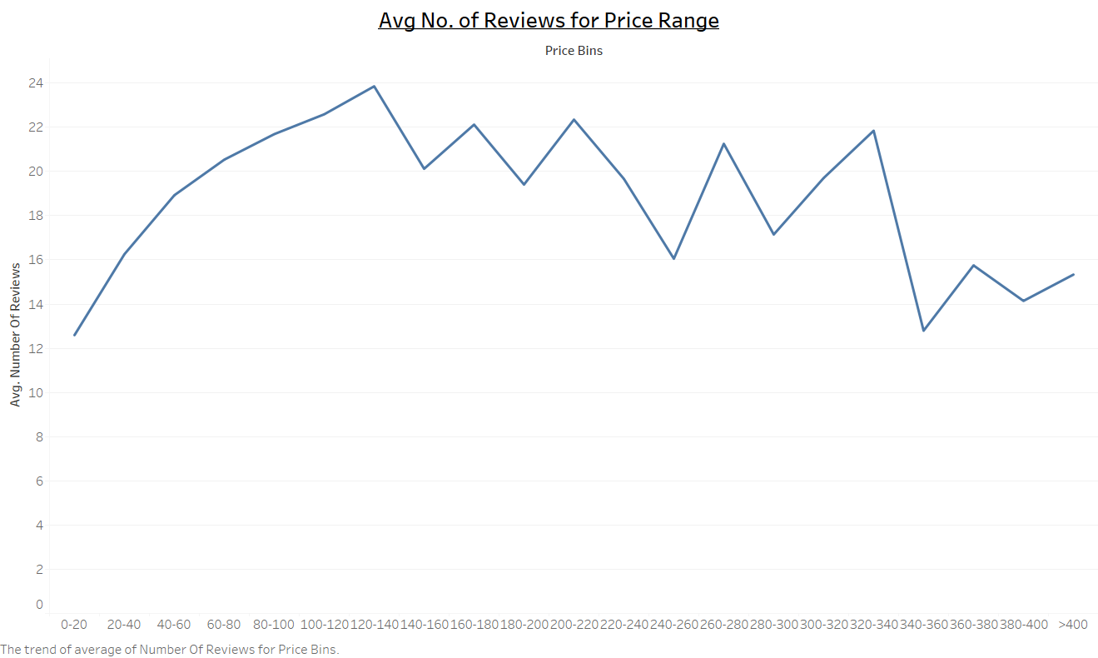

* Compared the trend for number of room bookings w.r.t number of minimum nights stay offered in each neighbourhood:

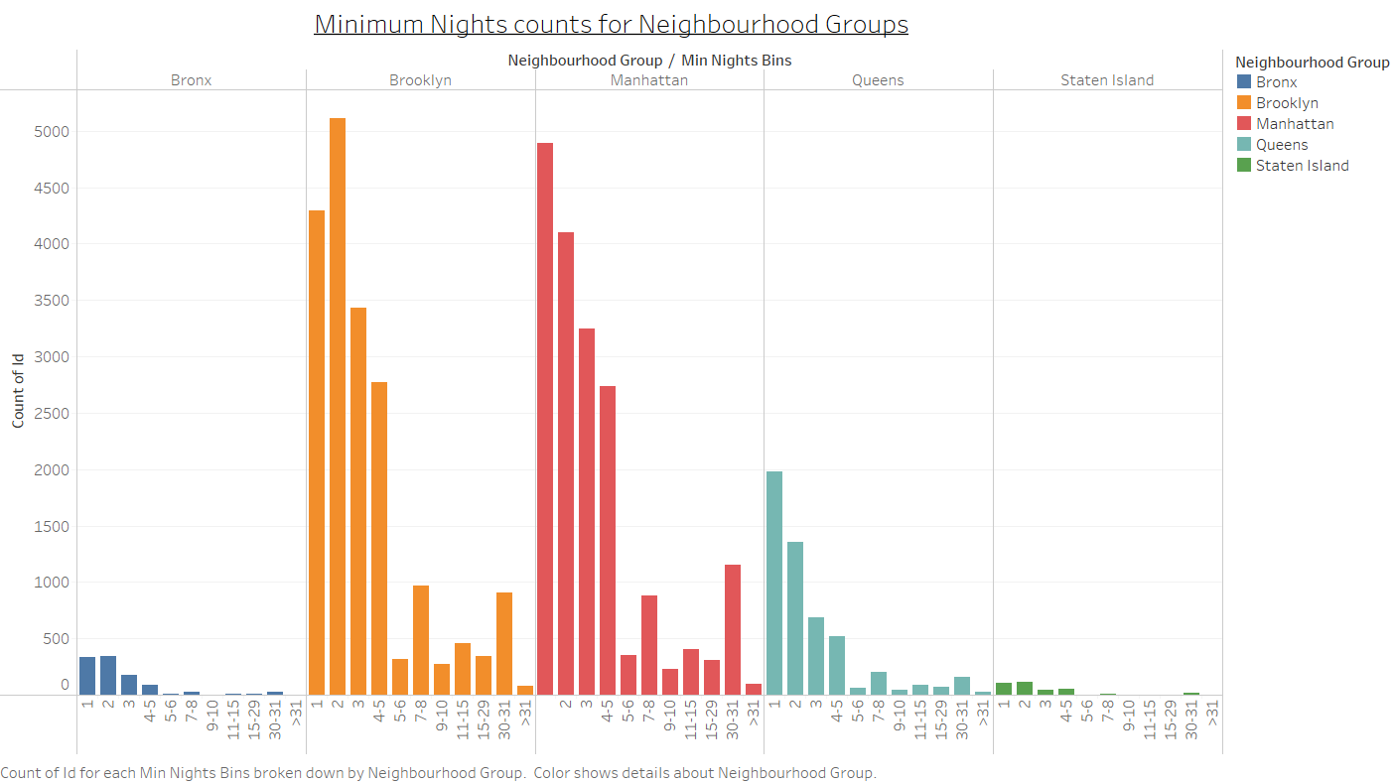

**Step 4: Presentation.**

* Made the presentation using the above given insights and visualization using the pyramid principle and keeping the best business practices in mind.